# Functional Requirements

## Required Functionality

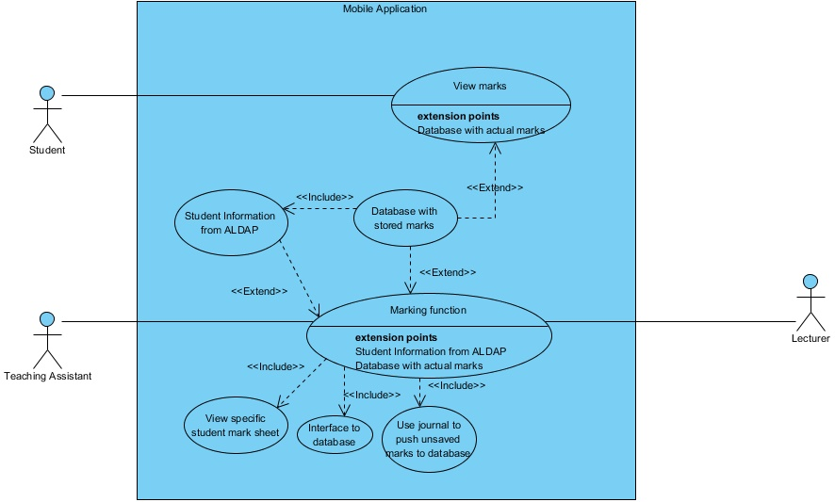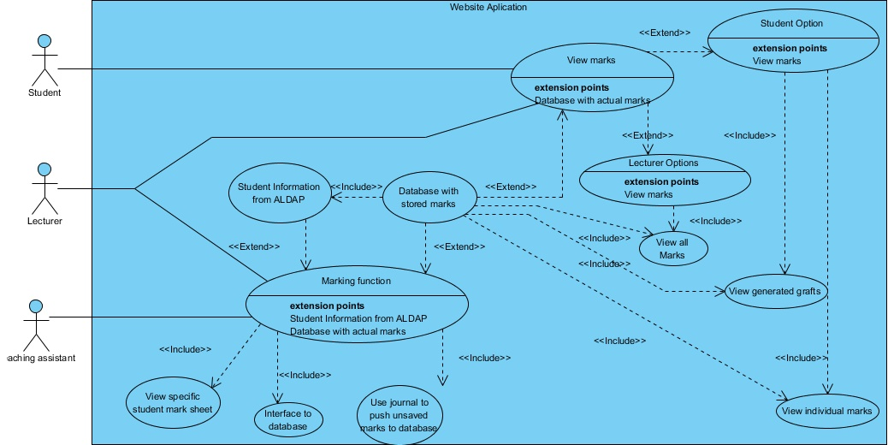

The following system processes describe the functional requirements of the system.

1. Downloading mobile application and installation
   1. Elaboration – Users shall be able to download the mobile version of this application from Google play store. The application is free.
   2. Importance – 4.
   3. Dependency level – Without downloading the application, users cannot make use of the applications functionality. Hence this process is a critical process.
   4. Pre-condition – User does not have mobile application.
   5. Post-condition – User has mobile application downloaded and installed on their mobile phones.
   6. Requestor – Client
2. Online access(WEB APPLICATION)
   1. Elaboration – Users shall be able to access online the web version of MMS from the specific link provided e.g. [www.mms.up.ac.za](http://www.mms.up.ac.za)
   2. Importance – 4.
   3. Dependency level – Without having access to internet, users cannot make use of the web application functionality. Hence this process is a critical process.
   4. Pre-condition – User does not have internet access on his/her computing device.
   5. Post-condition – User has internet access on their computing devices.
   6. Requestor – Client
3. Signing In
   1. Elaboration – Users of this system should be able to sign in in order to verify them as valid users of the system and allow them their given privileges on the system.
   2. Importance – 4.
   3. Dependency level – Without this process, users of this system will not have access to the system, which will render the system unusable.
   4. Pre-condition – This feature on the system will be properly implemented using appropriate technology.
   5. Post-condition – This feature functions as it should with no defects or short-comings.
   6. Requestor – Client.
4. Signing out
   1. Elaboration – Users of this system should be able to sign put in order to end their active usage session of the system for security reasons.
   2. Importance – 4.
   3. Dependency level – Without this process, users will not be able to sign out of their active sessions, which poses a great threat to the security of the system.
   4. Pre-condition – This feature on the system will be properly implemented using appropriate technology.
   5. Post-condition – This feature functions as it should with no defects or short-comings.
   6. Requestor – Client.
5. Adding lecturers to the system and assigning them to relevant modules.
   1. Elaboration – This process will allow the HOD to add lecturers in his department to the system and validate them as lecturers for their respective modules.
   2. Importance – 4.
   3. Dependency level – Without this feature, the entire system is unusable as lecturers cannot assign TAs and tutors to mark students using the system, hence the client request is not satisfied.
   4. Pre-condition – This feature on the system will be properly implemented using appropriate technology.
   5. Post-condition – This feature functions as it should with no defects or short-comings.
   6. Requestor – Client.
6. Administering system.
   1. Elaboration – This process will allow the HOD to administer the system and ensure that the system is operating smoothly.
   2. Importance – 2.
   3. Dependency level – Without this process, the system becomes open to fault that may possibly hinder the effective functioning of the system.
   4. Pre-condition – This feature on the system will be properly implemented using appropriate technology.
   5. Post-condition – This feature functions as it should with no defects or short-comings.
   6. Requestor – Client.
7. Reviewing the system.
   1. Elaboration – This process will allow the HOD and lecturers to view user activity on the system by reviewing audit logs to ensure that no misuse of the system occurs. It will also allow the HOD and lecturers to follow up on cases that may arise relating to student marks by reviewing user activity on the audit logs.
   2. Importance – 4.
   3. Dependency level – Given that no misuse occurs, this feature does not prove fatal to the operation of the system. However, Murphy’s Law suggests that if anything can go wrong, it will, hence it’s the auditability, security and effectiveness of the system may rely heavily on this feature.
   4. Pre-condition – This feature on the system will be properly implemented using appropriate technology.
   5. Post-condition – This feature functions as it should with no defects or short-comings.
   6. Requestor – Client.
8. Assigning markers to practical sessions and assigning students to markers.
   1. Elaboration – This process allows lecturers to assign markers to marking sessions and to assign that marker a selected group of students.
   2. Importance – 4.
   3. Dependency level – Without this feature, the system becomes ineffective as there are no markers assigned to record student marks.
   4. Pre-condition – This feature on the system will be properly implemented using appropriate technology.
   5. Post-condition – This feature functions as it should with no defects or short-comings.
   6. Requestor – Client.
9. To lock and finalize mark sheets for marking sessions once the session is complete.
   1. Elaboration – This process involves the system automatically locking a mark-sheet after practical session is compete, or the lecturer locking the mark-sheet himself/herself.
   2. Importance – 3.
   3. Dependency level – Without this process, markers may alter mark sheets whenever they wish, even long after the assessment was assessed, which poses security and validity threats.
   4. Pre-condition – This feature on the system will be properly implemented using appropriate technology.
   5. Post-condition – This feature functions as it should with no defects or short-comings.
   6. Requestor – Client.
10. To record students’ marks onto the system.
    1. Elaboration – This process involves the marker entering a student’s mark into the system.
    2. Importance – 4.
    3. Dependency – Without this process, the purpose of the system is defeated.
    4. Pre-condition – This feature on the system will be properly implemented using appropriate technology.
    5. Post-condition – This feature functions as it should with no defects or short-comings.
    6. Requestor – Client.
11. To alter students’ marks on the system.
    1. Elaboration – This process describes a marker altering a student mark on the system after having already recorded a mark for the student.
    2. Importance – 3.
    3. Dependency level – This process allows markers to correct a student’s mark which has been incorrectly recorded on the system. As the client wishes that lecturers have minimal to zero interaction with the mark-recording-process, this process is rather necessary.
    4. Pre-condition – This feature on the system will be properly implemented using appropriate technology.
    5. Post-condition – This feature functions as it should with no defects or short-comings.
    6. Requestor – Client.
12. Import/Export .csv files
    1. Elaboration – Users of this system shall be able to import or export marks to and from the system in csv format.
    2. Importance – 2
    3. Dependency level – The system is not highly dependent on this process, and can still function to its purpose without this process.
    4. Pre-condition – 1. User wishes to download mark sheet in csv format.

2. User wishes to upload mark sheet in csv format.

* 1. Post-condition – 1. User successfully downloaded mark sheet in csv format.

2. User successfully uploaded marks in csv format.

1. To view marks on the system.
   1. Elaboration – This process describes students, lecturers, and the HOD being able to view a student’s marks on the system. Student marks should be visible as individual and cumulative marks till any given point in time. These marks should also have statistical measures and graphical representations such as graphs.
   2. Importance – 4
   3. Dependency level – Without this process, the purpose of the system is defeated.
   4. Pre-condition – This feature on the system will be properly implemented using appropriate technology.
   5. Post-condition – This feature functions as it should with no defects or short-comings.
   6. Requestor – Client.
2. Record changes on Audit book
   1. Elaboration – There shall be an audit book that will keep records of every edit that is being done on the mark sheet(s). It will only record changes that happens when the marks are being edited on the mark sheet(s).
   2. Importance – 4
   3. Dependency level – This feature will provide full monitoring on tempering will mark sheet(s) on the system, the system needs it.
   4. Pre-condition – no changes are made on the mark sheet(s) that has been locked, nothing will be recorded on the audit book.
   5. Post-condition – change(s) is made to the mark sheet(s) that was locked, it change(s) is recorded with reason why it was made.
   6. Requestor – Client
3. Search ability
   1. The system shall be able to allow users to search using key words such as name, surname and students number. The keeps the history of what has been searched for on that session.
   2. Importance – 2
   3. Dependency level – This feature will make the system more easy to use and simple to use.
   4. Pre-condition – nothing has been typed on the search bar, no search is made.
   5. Post-condition – keyword has been typed on the search bar, the system automatically filters content with relevance to the keyword.
   6. Requestor – Client
4. Generating report
   1. HODs and Lectures shall be able to generate report on their modules at any level of precedence. The report is in pdf format and it contains graphs and other necessary records about the module.
   2. Importance – 3
   3. Dependency level – this feature is very useful since it adds value to the system of producing clear indication of what is happening on modules to lectures and HODs.
   4. Pre-condition – no request has been made on any level of precedence.
   5. Post-condition – request has been made of the report at some level of precedence, it will be generated in pdf format.
   6. Requestor – Client